**Lab Assignment-1**

Name: Khushi Prasad

SubGroup: 3CO20

Roll No.: 102183044

Subject: Data Science Fundamentals

Q1. Assign and print the values 23.4, 45 and 678 to the variables A, B, C.

CODE:



OUTPUT:

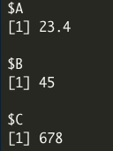

Q2. Display the entire variable you have created on the screen.

CODE:



OUTPUT:

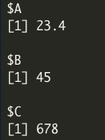

Q3. Remove the variable C and display the list.

CODE:



OUTPUT:

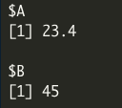

Q4. Create a comment “I am learning R”

CODE:



OUTPUT:



Q5. Create strings firstname and lastname as “MyName” and “MySurname”

CODE:

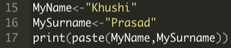

OUTPUT:



Q6. Create the variable that can hold a value as 0 or 1.

CODE:

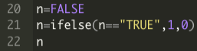

OUTPUT:



Q7. Perform the operation as +, -, * and / on variables A, B, C together.

CODE:

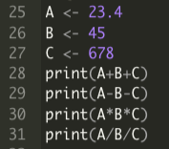

OUTPUT:

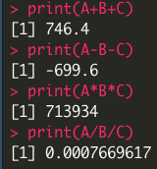

Q8. Apply the following functions on some values: Exp(), log(), log10(), log2(), pi, sqrt()

CODE:

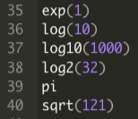

OUTPUT:

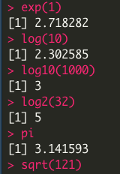

Q9. Write the statement to solve the following expressions:

1. 23 + (4.5 * 2.3) / 10

2. 456 / 12 – log(90)

3. Exp(5) + 12 / (5 ^ 6)

4. sqrt(45)*12/3

CODE:

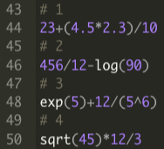

OUTPUT:

